Meet-Meet Design Document

The design for Meet-Meet is made up of several individual components. The first component will be a Graphical User Interface (GUI) that the user will interact with. The second component will be the C# code that will be compiled to native code which will run on a user’s device. Finally, we will create the backend database to store user data for the long term. To help us meet these goals we will be using a program called Xamarin to compile C# code and provide a GUI builder, the free service tier of Amazon Web Services (AWS) to host our server and database. Finally, we will be using Google Cloud Messaging (GCM) to push notifications to our user’s devices. Our application must be able to access the user’s location and use that information to match them with other users in the same area. Thus, it is essential for us find a user’s location, as well as efficiently finding other users within the same area.

The GUI for Meet-Meet will be fairly simplistic, we will allow a user to sign up for the service in the app. The main menu will have buttons for signing up and signing in, when the user clicks a button, they will be taken to the appropriate page. The signup page will include a “sign up” button and the following fields: username, password and password confirmation. The login page will simply have username and password. Once users are signed up, they are taken to an edit profile page where they can set their gender and bio. After that, users will be taken to the home menu where they can set their location, find nearby users or send messages, logout, edit their profile or delete their account. The “find nearby users” menu will display a list of usernames within a 5-mile radius, and when a username is selected, that user’s gender, bio, upvotes and downvotes will be displayed. A user may be selected by double clicking, which will take the current user to an option menu, in this menu users will also be able to view the profile of other users in the area, the profile screen will display the following information: Username, gender, bio, the report rating of the user, and buttons for upvoting, downvoting, inviting (to group), blocking and unblocking. The user can also send messages to nearby users using the “send message” button from the main menu. Here the user can select another nearby user, write a message, and send it. The “group message” menu merely has a text field and a button, which the user can use to send a message to their entire group (if they are currently in one). We made the conscious decision to not include profile pictures, mainly because the users are in such close proximity to each other and we don’t want to allow one user to find another with the consent of both.

The most important aspect of Meet-Meet is the location based grouping. This is the backbone of our application and it is imperative that it works properly. To accomplish this goal we set up a database containing information about our users as well as their current location. When a user asks our application to get the list of other users nearby, we send a request to our server which uses the “great circle distance” formula to find all the other users within a set radius (in our case, 5 miles). Our application presents users with the profiles of others in the area. This allows the user to view the information about the other users and potentially send them a message, if they desire. Contact is done as a messaging service through the app using Google Cloud Messaging (GCM). When a user sends a message, the message is first sent to our AWS server, from there we process it. The first thing we check for is to make sure that the users have not blocked each other. If they have not, we then match our custom username to a GCM regid, which will be used by the Google servers. Once the regid(s) has been found (if they exist), the message and the regid(s) of the receiving user(s) are forwarded on to the GCM servers which handle the actual message delivery. Once a message has been received by our application, we display a notification to the user, or perform some message specific action (such as opening an invite menu). As implied earlier, we use messages not only to communicate between users, but also to do utility tasks, such as notify a user of a group invite. If a user accepts an invite, a group is formed (or the user is added to a pre-existing group). Once a group has been formed, the users in the group may make use of the group messaging functionality to message all of the users in the group at once.

We utilized Amazon Web Service’s (AWS) free service tier to host our server side operations. Our server is running Linux, we are using Node.js for our webapi, BCrypt for securely hashing passwords, and MySQL for our data storage needs. Our database has evolved over time as we updated and refined what we wanted our software to be. We removed much of the personal information about users and added a lot of utility information. The only personal information that our database currently stores is the usernames, hashed passwords, bios and the gender of our users. However, we have had to add information which the user generates through their use of the app. This information includes: session tokens, the id of the group the user is in (if applicable), the users that the user has blocked, the rating of a user, the GCM regid, used to identify the user’s device and their latitude and longitude. We initially planned to store the interests and language of a user, to be used, if possible, for matching users based on more than location. However, we were unable to attain these stretch goals, and as such, we decided it would make more sense to remove these restrictions and simply allow the user to create a general bio where they could write any information they wanted.

**Example user sign up and match GUIs:**

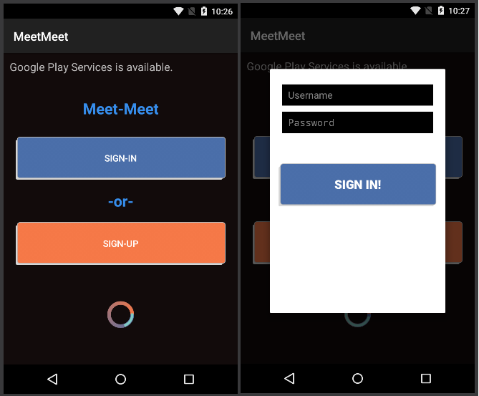

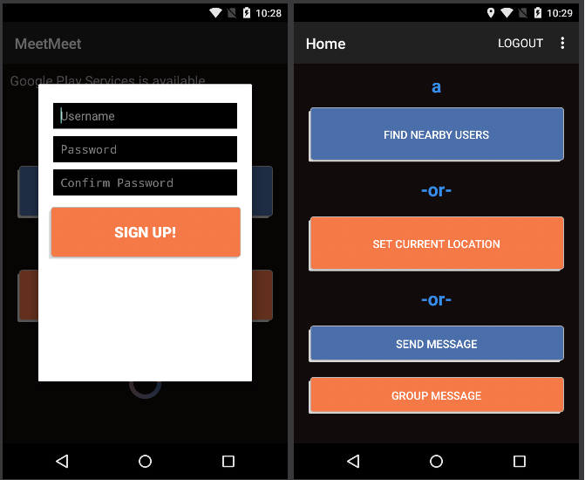

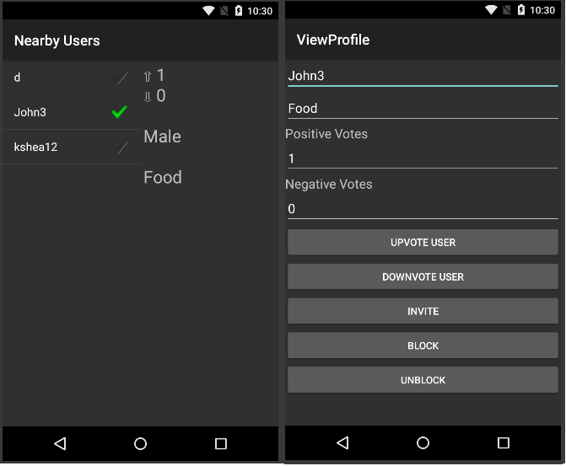

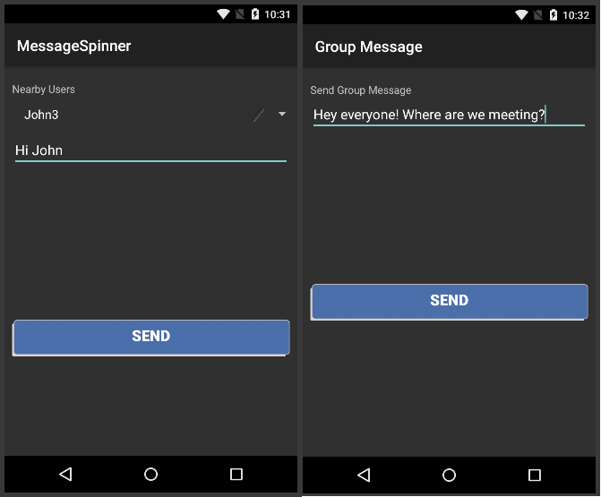

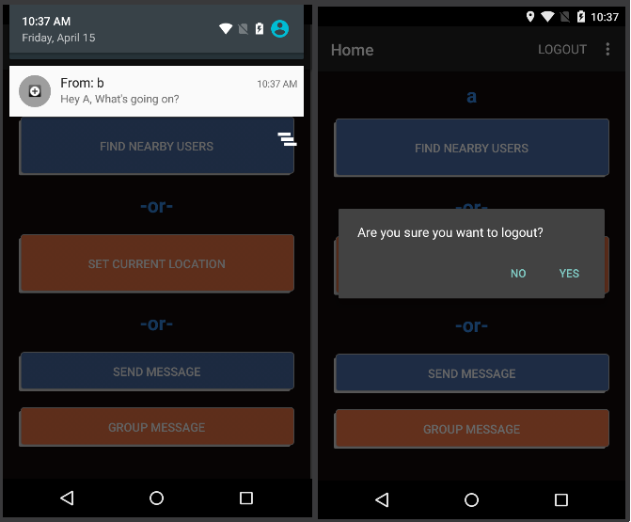

**Choices of IDE**

We originally were going to exclusively develop on the Android device, therefore we used the official IDE called Android Studio. Some group members had trouble with the IDE and used what Android Studio was based off of and that was IntelliJ. Then we decided to go to the cross platforming IDE for our app and decided to use Xamarin which provided us with a free one year license.

**Choices of Servers**

We thought about using Heroku as our web server provider as it did provide a free level though a little more limited than Amazon Web Service. Heroku highlights the ability to link github files straight onto the server. This seemed promising but Heroku lacked a good tutorial and API to use it, so we looked into Amazon Web Service instead. AWS’s free tier service provides 24/7 server uptime and a relational database with respectable processing speed. They also had a very detailed walkthrough on how to setup the server, database, apache web service, and mySQL.

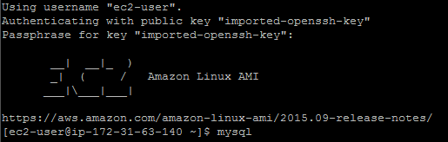

**Web API**

We are developing our web API using Node.js with the Express package framework, REST software architectural style and utilizing the JSON format of information passing. It will be designed RESTfully with nouns in the URI to avoid confusing verbs. The principle behind this is because it is cumbersome to have URI for actions such as “deletePerson” and “writePerson”. It is better to create noun keywords in the URI such as “Person” with a delete request will delete all persons. “Person/John” with a put request will add a person named John and “Person/John with delete request will delete John. This utilizes the four different requests used in RESTful calls.

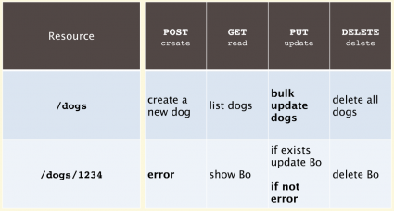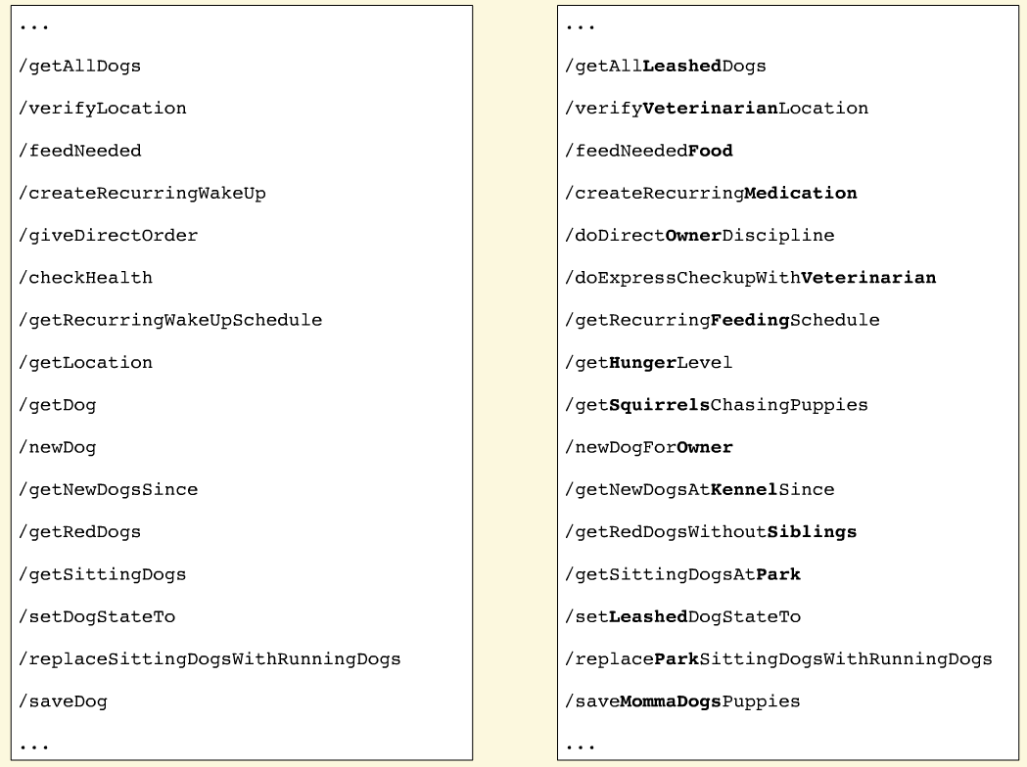

**Sample Web API requests**

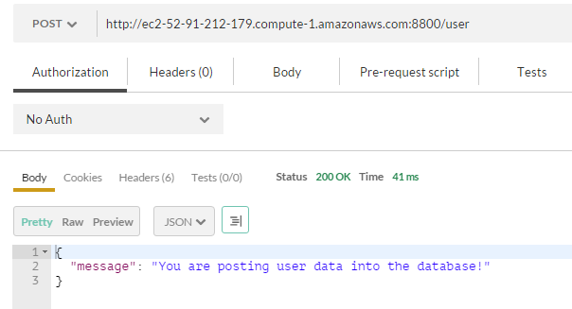

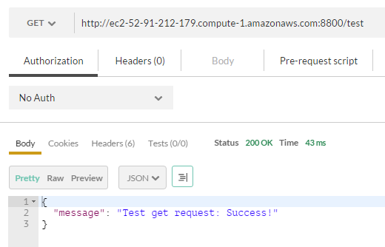

**Choices of Databases**

mySQL is offered by Amazon Web services and we choose it because we are most familiar with it. The database is relational so we can abstract our tables if needed.

**Test database tables**

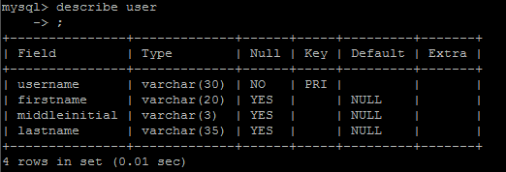

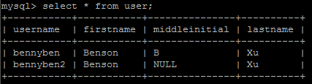

**Sample database table design**

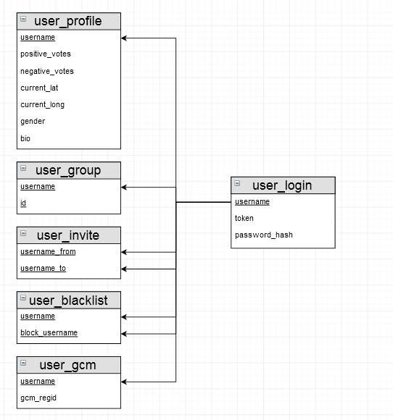

**Geolocation matching overview**

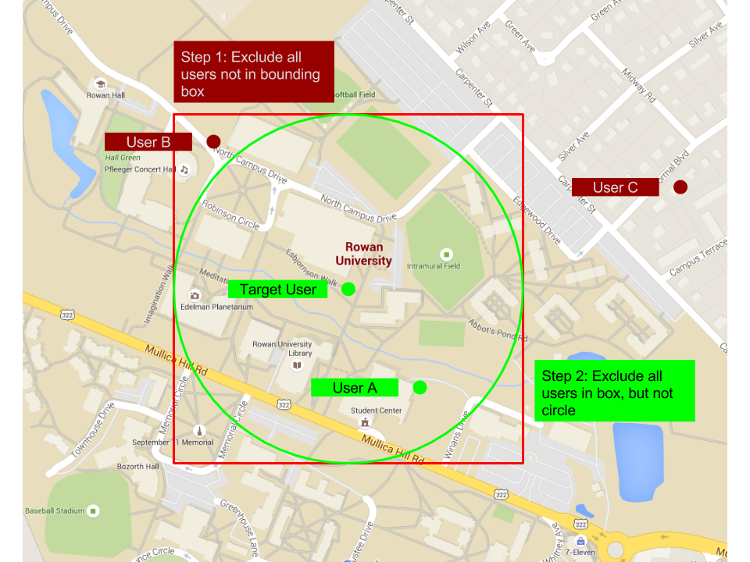

This picture shows how our software will determine geolocation matches. In this first step, we exclude all points outside of the bounding box. This is a fairly efficient task to do and it will greatly reduce the number of possible matches. After we have excluded points using the box, we individually calculate the distance between the target point and the remaining points, discarding any that aren’t within the target radius.

In this example, user C would be excluded by step 1, users A and B would not. Step 2 would eliminate user B. And finally, the program would present the target user with user A as a potential match.

**References**

1. <http://janmatuschek.de/LatitudeLongitudeBoundingCoordinates>

**Document revisions**

This document was originally a Word document hosted on GitHub. It was then moved to Google Docs where the majority of the work was done. In order to see the revision history, the Google Doc can been found at this link: <https://docs.google.com/a/students.rowan.edu/document/d/1i59oqPVazMxky7acjp7WOxpwQclsC4_p24nLkEL3YfU/edit?usp=sharing>